5-variant

<!DOCTYPE html>

<html lang="en">

<head>

    <meta charset="UTF-8">

    <meta http-equiv="X-UA-Compatible" content="IE=edge">

    <meta name="viewport" content="width=device-width, initial-scale=1.0">

    <title>5-variant</title>

    <link rel="stylesheet" href="./assets/css/all.css">

    <link rel="stylesheet" href="./assets/css/style.css">

</head>

<body>

  <div class="container">

    <div class="sidebar">

        <div class="name">Jo'rayev Mansur</div>

        <div class="name2">JM</div>

        <ul class="links">

          <li class="link_item"><a class="active" href="/"> <i class="fa fa-home"></i> <div>Home</div></a></li>

          <li class="link_item"><a href="about.html"><i class="fa fa-info-circle" aria-hidden="true"></i><div>About</div></a></li>

          <li class="link_item"><a href="video.html"><i class="fas fa-video"></i><div>Video</div></a></li>

          <li class="link_item"><a href="login.html"><i class="fas fa-sign-in-alt"></i><div>Login</div></a></li>

        </ul>

    </div>

    <div class="content">

        <div class="mainContent">

          <div class="name">Jo'rayev Mansur </div>

          <div class="subItem">Full stack web developer</div>

        </div>

        <div class="skills">

          <div class="skill_item">

            <div class="title">HTML, CSS,JS,SCSS, Resposive design </div>

            <div class="percent"> 90%</div>

          </div>

          <div class="skill_item">

            <div class="title">React, Redux and React Hooks </div>

            <div class="percent">90%</div>

          </div>

          <div class="skill_item">

            <div class="title">NodeJs, MongoDB(Express) </div>

            <div class="percent"> 90%</div>

          </div>

          <div class="skill_item">

            <div class="title">Linux, Apache, Nginx, Server configuration and security,Load balancing </div>

            <div class="percent"> 90%</div>

          </div>

        </div>

    </div>

    <div class="area ">

      <div class="icons ">

          <a href="mailto:jurayevmansurbek667@gmail.com" class=" icon " >

              <i class="fab fa-google item "></i>

              <span class="animate_block ">

              </span>

          </a>

          <a href="https://t.me/Jurayev_Mansur" target="_blank" class="icon ">

              <i class="fab fa-telegram item "></i>

              <span class="animate_block ">

              </span>

          </a>

          <a href="https://www.facebook.com/mss0105" target="_blank" class="icon " >

              <i class="fab fa-facebook-f item "></i>

              <span class="animate_block ">

              </span>

          </a>

          <a class="icon "href="https://www.youtube.com/channel/UCqs8VKrYTzOk3KNiOscOJJQ" target="_blank" >

              <i class="fab fa-youtube item "></i>

              <span class="animate_block ">

              </span>

          </a>

      </div>

  </div>

  </div>

</body>

<script src="./assets/js/all.js"></script>

</html>

Index.html

<!DOCTYPE html>

<html lang="en">

<head>

    <meta charset="UTF-8">

    <meta http-equiv="X-UA-Compatible" content="IE=edge">

    <meta name="viewport" content="width=device-width, initial-scale=1.0">

    <title>5-variant</title>

    <link rel="stylesheet" href="./assets/css/all.css">

    <link rel="stylesheet" href="./assets/css/style.css">

</head>

<body>

  <div class="container">

    <div class="sidebar">

      <div class="name">Jo'rayev Mansur</div>

      <div class="name2">JM</div>

      <ul class="links">

        <li class="link_item"><a  href="/"> <i class="fa fa-home"></i> <div>Home</div></a></li>

        <li class="link_item"><a  href="about.html"><i class="fa fa-info-circle" aria-hidden="true"></i><div>About</div></a></li>

        <li class="link_item"><a class="active" href="video.html"><i class="fas fa-video"></i><div>Video</div></a></li>

        <li class="link_item"><a href="login.html"><i class="fas fa-sign-in-alt"></i><div>Login</div></a></li>

      </ul>

    </div>

    <div class="content">

      <div class="mainContent">

        <div class="name">Jo'rayev Mansur </div>

        <div class="subItem">Full stack web developer</div>

      </div>

      <div class="video">

        <div class="title">Talıb Tale & Zeynəb Həsəni - Səbr Elə</div>

        <video  controlsList="nodownload" controls >

            <source src="./assets/video/videoplayback.mp4" type="video/mp4">

        </video>

      </div>

      <div class="area ">

        <div class="icons ">

            <a href="mailto:jurayevmansurbek667@gmail.com" class=" icon " >

                <i class="fab fa-google item "></i>

                <span class="animate_block ">

                </span>

            </a>

            <a href="https://t.me/Jurayev_Mansur" target="_blank" class="icon ">

                <i class="fab fa-telegram item "></i>

                <span class="animate_block ">

                </span>

            </a>

            <a href="https://www.facebook.com/mss0105" target="_blank" class="icon " >

                <i class="fab fa-facebook-f item "></i>

                <span class="animate_block ">

                </span>

            </a>

            <a class="icon "href="https://www.youtube.com/channel/UCqs8VKrYTzOk3KNiOscOJJQ" target="_blank" >

                <i class="fab fa-youtube item "></i>

                <span class="animate_block ">

                </span>

            </a>

        </div>

    </div>

    </div>

  </div>

</body>

<script src="./assets/js/all.js"></script>

</html>

Video.html fayli

<!DOCTYPE html>

<html lang="en">

<head>

    <meta charset="UTF-8">

    <meta http-equiv="X-UA-Compatible" content="IE=edge">

    <meta name="viewport" content="width=device-width, initial-scale=1.0">

    <title>5-variant</title>

    <link rel="stylesheet" href="./assets/css/all.css">

    <link rel="stylesheet" href="./assets/css/style.css">

</head>

<body>

  <div class="container">

    <div class="sidebar">

      <div class="name">Jo'rayev Mansur</div>

      <div class="name2">JM</div>

      <ul class="links">

        <li class="link_item"><a  href="/"> <i class="fa fa-home"></i> <div>Home</div></a></li>

        <li class="link_item"><a  href="about.html"><i class="fa fa-info-circle" aria-hidden="true"></i><div>About</div></a></li>

        <li class="link_item"><a href="video.html"><i class="fas fa-video"></i><div>Video</div></a></li>

        <li class="link_item"><a class="active" href="login.html"><i class="fas fa-sign-in-alt"></i><div>Login</div></a></li>

      </ul>

    </div>

    <div class="content">

      <div class="mainContent">

        <div class="name">Jo'rayev Mansur </div>

        <div class="subItem">Full stack web developer</div>

      </div>

      <div class="login">

        <div class="box">

          <div class="title">Login</div>

          <div class="field">

            <label for="login">Login:</label>

            <input id="login" type="text" name="" id="">

          </div>

          <div class="field">

            <label for="password">Password:</label>

            <input id="password" type="password" name="" id="">

          </div>

          <button class="submitBtn">Submit</button>

        </div>

      </div>

      <div class="area ">

        <div class="icons ">

            <a href="mailto:jurayevmansurbek667@gmail.com" class=" icon " >

                <i class="fab fa-google item "></i>

                <span class="animate_block ">

                </span>

            </a>

            <a href="https://t.me/Jurayev_Mansur" target="_blank" class="icon ">

                <i class="fab fa-telegram item "></i>

                <span class="animate_block ">

                </span>

            </a>

            <a href="https://www.facebook.com/mss0105" target="_blank" class="icon " >

                <i class="fab fa-facebook-f item "></i>

                <span class="animate_block ">

                </span>

            </a>

            <a class="icon "href="https://www.youtube.com/channel/UCqs8VKrYTzOk3KNiOscOJJQ" target="_blank" >

                <i class="fab fa-youtube item "></i>

                <span class="animate_block ">

                </span>

            </a>

        </div>

    </div>

    </div>

  </div>

</body>

<script src="./assets/js/all.js"></script>

</html>

Login.html fayli

<!DOCTYPE html>

<html lang="en">

<head>

    <meta charset="UTF-8">

    <meta http-equiv="X-UA-Compatible" content="IE=edge">

    <meta name="viewport" content="width=device-width, initial-scale=1.0">

    <title>5-variant</title>

    <link rel="stylesheet" href="./assets/css/all.css">

    <link rel="stylesheet" href="./assets/css/style.css">

</head>

<body>

  <div class="container">

    <div class="sidebar">

      <div class="name">Jo'rayev Mansur</div>

      <div class="name2">JM</div>

      <ul class="links">

        <li class="link_item"><a  href="/"> <i class="fa fa-home"></i> <div>Home</div></a></li>

        <li class="link_item"><a class="active" href="about.html"><i class="fa fa-info-circle" aria-hidden="true"></i><div>About</div></a></li>

        <li class="link_item"><a href="video.html"><i class="fas fa-video"></i><div>Video</div></a></li>

        <li class="link_item"><a href="login.html"><i class="fas fa-sign-in-alt"></i><div>Login</div></a></li>

      </ul>

    </div>

    <div class="content">

      <div class="mainContent">

        <div class="name">Jo'rayev Mansur </div>

        <div class="subItem">Full stack web developer</div>

      </div>

      <div class="aboutMe">Men Jo'rayev Mansur 2001-yilda Qashqadaryo viloyati Chiroqchi tumani Navro'z qishlog'ida tug'ilganman. 2008-yil 46-Umumta'lim maktabining 1 sinfiga qabul qilinib 2019-yilda shu maktabinng 11-sinfini bitirdim. 2019-yilda men Toshkent Axborot Texnologiyalari Universitetining "Kompyuter injinirinig:AT-servis " fakultetiga o'qishga topshirib Byudjet asosida o'qishga qabul qilindim. Hozirda Shu Universitetining 2-kurs talabasiman.</div>

    </div>

    <div class="area ">

      <div class="icons ">

          <a href="mailto:jurayevmansurbek667@gmail.com" class=" icon " >

              <i class="fab fa-google item "></i>

              <span class="animate_block ">

              </span>

          </a>

          <a href="https://t.me/Jurayev_Mansur" target="_blank" class="icon ">

              <i class="fab fa-telegram item "></i>

              <span class="animate_block ">

              </span>

          </a>

          <a href="https://www.facebook.com/mss0105" target="_blank" class="icon " >

              <i class="fab fa-facebook-f item "></i>

              <span class="animate_block ">

              </span>

          </a>

          <a class="icon "href="https://www.youtube.com/channel/UCqs8VKrYTzOk3KNiOscOJJQ" target="_blank" >

              <i class="fab fa-youtube item "></i>

              <span class="animate_block ">

              </span>

          </a>

      </div>

  </div>

  </div>

</body>

<script src="./assets/js/all.js"></script>

</html>

About.html fayli

Css orqali stil berish

*, *::after, *::before{

    padding: 0;

    margin: 0;

    box-sizing: border-box;

}

    @import './partials/sidebar';

    @import './partials/index';

    @import './partials/about';

    @import './partials/video';

    @import './partials/login';

    @import './partials/footer';

    .container{

        display: flex;

        width: 100%;

        height: 100vh;

    }

    .content{

        padding: 30px;

        padding-top: 0;

        display: flex;

        overflow-x: hidden;

        overflow-y: auto;

        flex-direction: column;

        width: 100%;

        background-color: rgb(43, 43, 43);

    }

    @media screen and (max-width:926px) {

        .content{

            padding: 10px;

        }

    }

Style.scss

Sass stilllash texnologiyasining imkoniyatida foydalanib stillarni partials(qismlarga ajratib ) stil beramiz.

*, *::after, *::before{

    padding: 0;

    margin: 0;

    box-sizing: border-box;

}

    @import './partials/sidebar';

    @import './partials/index';

    @import './partials/about';

    @import './partials/video';

    @import './partials/login';

    @import './partials/footer';

    .container{

        display: flex;

        width: 100%;

        height: 100vh;

    }

    .content{

        padding: 30px;

        padding-top: 0;

        display: flex;

        overflow-x: hidden;

        overflow-y: auto;

        flex-direction: column;

        width: 100%;

        background-color: rgb(43, 43, 43);

    }

    @media screen and (max-width:926px) {

        .content{

            padding: 10px;

        }

    }

_about.scss

.area {

    // padding: 20px 0;

    display: flex;

    // background-color: black;

    position: fixed;

    bottom: 0;

    left: 0;

}

.icons {

    display: flex;

    flex-direction: column;

}

$widthIcon :40px;

.icon {

    background: white;

    position: relative;

    margin: 5px;

    width: $widthIcon;

    height: $widthIcon;

    display:flex;

    align-items: center;

    justify-content: center;

    padding: 13px;

    border: 2px solid lightblue;

    border-radius: 13%;

    z-index: 4;

}

.item {

    // width: 40px;

    // height: 40px;

    opacity: 1;

    font-size: larger;

    color: lightblue;

    cursor: pointer;

}

.fab::after,

.fab::before {

    z-index: 2;

}

.fa-google {

    color: tomato;

}

.fa-facebook-f {

    color: rgb(22, 22, 114);

}

.fa-youtube {

    color: red;

}

.fa-telegram {

    color: rgb(0, 126, 243);

}

.icon:hover .fa-google {

    color: rgb(0, 4, 247);

}

.icon:hover .fa-telegram {

    color: rgb(2, 255, 116)

}

.icon:hover .fa-facebook-f {

    color: rgb(250, 78, 78)

}

.icon:hover .fa-youtube {

    color: rgb(8, 8, 8)

}

.animate_block {

    position: absolute;

    width: 100%;

    height: 100%;

    opacity: 0.5;

    /* border: 0.5px solid white; */

    bottom: 0%;

    left: 0px;

}

.icon:hover .animate_block {

    background-color: rgb(69, 183, 228);

    width: 100%;

    height: 100%;

    bottom: 0%;

    left: 0px;

    z-index: 2;

    border-radius: 13%;

    cursor: pointer;

    animation: enter 0.3s ease-in;

}

@keyframes enter {

    0% {

        background-color: rgb(69, 183, 228);

        width: 0%;

        opacity: 0;

        height: 0%;

        bottom: 0%;

        left: 0px;

        border-bottom-left-radius: 60%;

        border-top-right-radius: 0%;

        z-index: 2;

    }

    50% {

        background-color: rgb(69, 183, 228);

        width: 100%;

        height: 100%;

        opacity: 0.5;

        bottom: 0%;

        left: 0px;

        border-bottom-left-radius: 60%;

        border-top-right-radius: 50%;

        z-index: 2;

    }

    100% {

        background-color: rgb(69, 183, 228);

        width: 100%;

        height: 100%;

        opacity: 1;

        bottom: 0%;

        left: 0px;

        border-bottom-left-radius: 0%;

        border-top-right-radius: 0%;

        z-index: 2;

    }

}

_footer.scss

.sidebar{

    width: 300px;

    background-color: black;

    color: white;

    font-family: -apple-system, BlinkMacSystemFont, 'Segoe UI', Roboto, Oxygen, Ubuntu, Cantarell, 'Open Sans', 'Helvetica Neue', sans-serif;

    .name, .name2{

        width: 100%;

        text-align: center;

        font-size: 24px;

        font-weight: 700;

        padding: 20px;

        margin-bottom: 20px;

        border-bottom: 2px solid rgba(255, 255, 255, 0.295);

    }

    .name2{

        display: none;

    }

    .links{

        display: flex;

        flex-direction: column;

        list-style: none;

        .link_item{

            &.active{

                border-left: 2px solid white;

            }

            display: flex;

            width: 100%;

            height: fit-content;

            // transition-property: color;

            // transition-duration: .8s;

            a{

                position: relative;

                transition:all .3s ease-in-out;

                width: 100%;

                padding: 15px 40px;

                text-decoration: none;

                color: inherit;

                display: flex;

                align-items: center;

                svg{

                    margin-right: 5px;

                }

                &:after{

                    transition:all .3s ease-in;

                    position: absolute;

                    content: "";

                    top: 0;

                    left: 0;

                    height: 100%;

                    width: 0%;

                    // border-top-right-radius: 50px;

                    opacity: 0;

                    // border-bottom-right-radius: 50px;

                }

                &:hover{

                    // background-color: rgba(255, 255, 255, 0.226);

                    color: rgb(150, 150, 150);

                    cursor: pointer;

                }

                &.active, &:hover::after{

                    opacity: 1;

                    // box-shadow: 10px 0 10px rgba(255, 255, 255, 0.329);

                    background-color: rgba(240, 255, 255, 0.308);

                    width: 100%;

                }

                &:active{

                    // transition:all .2s ease;

                    background-color: azure;

                }

            }

        }

    }

}

@media screen and (max-width:926px) {

    .sidebar{

        width: min-content;

        .name{

            display: none;

        }

        .name2{

            display: flex;

            align-items: center;

            justify-content: center;

            padding: 10px;

        }

        .links{

            margin-top: 40px;

            .link_item{

               a{

                padding: 10px;

                div{

                   display: none;

                }

                svg{

                   font-size: 23px;

                }

               }

            }

        }

    }

}

_sidebar.scss

.login{

    display: flex;

    width: 100%;

    position: relative;

    flex-direction: column;

    height: 100%;

    justify-content: center;

    align-items: center;

    .box{

        display: flex;

        flex-direction: column;

        justify-content: center;

        width: 100%;

        background: rgb(26, 26, 26);

            max-width: 600px;

            padding: 60px 40px;

            border-radius: 10px;

            box-shadow:0 0 10px rgb(83, 83, 83) ;

        // width: 100%;

        .title{

            font-size:34px;

            font-weight: 900;

            letter-spacing: 5px;

            padding: 10px;

            text-align: center;

        }

        .field{

            flex-direction: column;

            display: flex;

            padding: 20px 0;

            label{

                font-size: 14px;

                font-weight: 500;

                margin-bottom: 4px;

            }

            input{

                outline:none;

                border: none;

                color: rgb(167, 167, 167);

                font-size: 23px;

                padding: 5px 2px;

                background: none;

                border-bottom: 2px solid rgb(66, 66, 66);

                width: 100%;

                display: flex;

                // padding: 20px;

                &:focus{

                    border-bottom: 2px solid rgb(136, 136, 136);

                }

            }

        }

        .submitBtn{

            transition:all .4s ease;

            margin: 0 auto;

            margin-top: 30px;

            display: flex;

            border-radius: 5px;

            width: min-content;

            text-align: center;

            justify-content: center;

            background: rgb(109, 109, 109);

            color: white;

            font-size: 20px;

            font-weight: 600;

            border: none;

            cursor: pointer;

            outline: none;

            padding: 10px 60px;

            &:hover{

                background: rgb(155, 155, 155);

                box-shadow: 0 0 3px rgb(155, 155, 155) ;

            }

        }

    }

}

_login.scss

.video{

    display: flex;

    flex-direction: column;

    .title{

        padding: 10px 0;

    }

    video{

        max-width: 600px;

        width: 100%;

        margin: 0 auto;

    }

    video::-internal-media-controls-download-button {

        display:none;

    }

    video::-webkit-media-controls-enclosure {

        overflow:hidden;

    }

    video::-webkit-media-controls-panel {

        width: calc(100% + 30px); /* Adjust as needed */

    }

}

_Video.scss

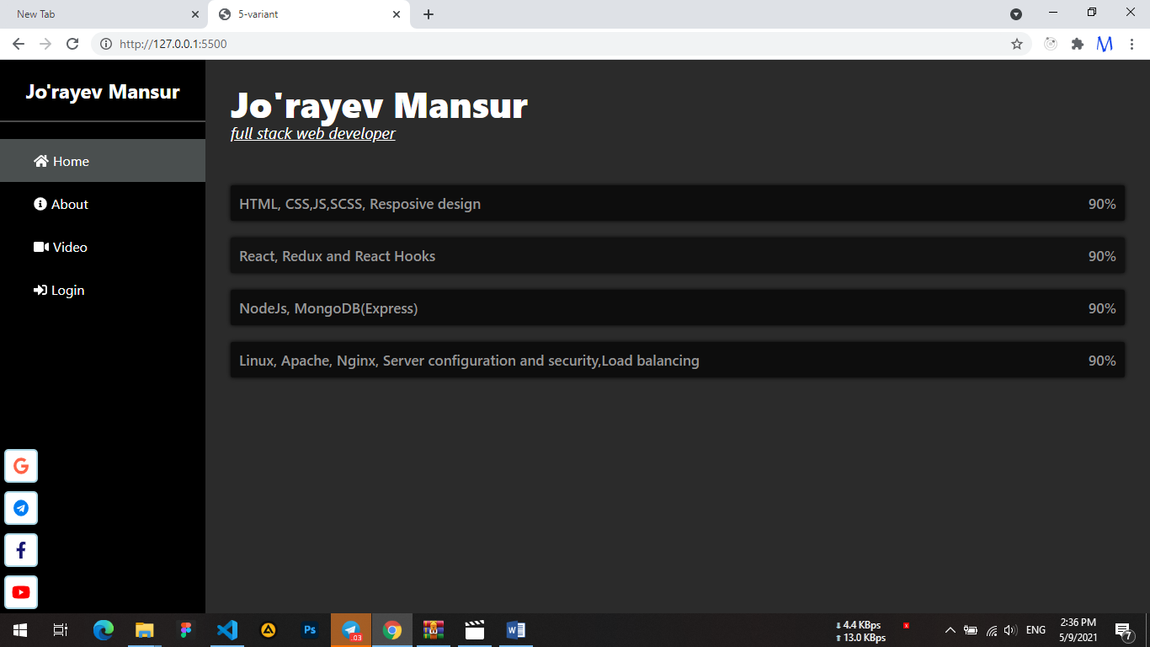

Index.html

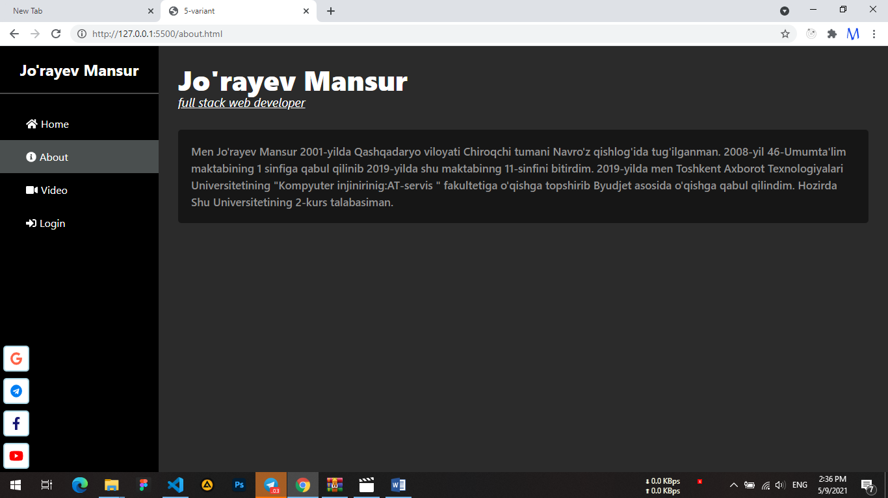

About.html

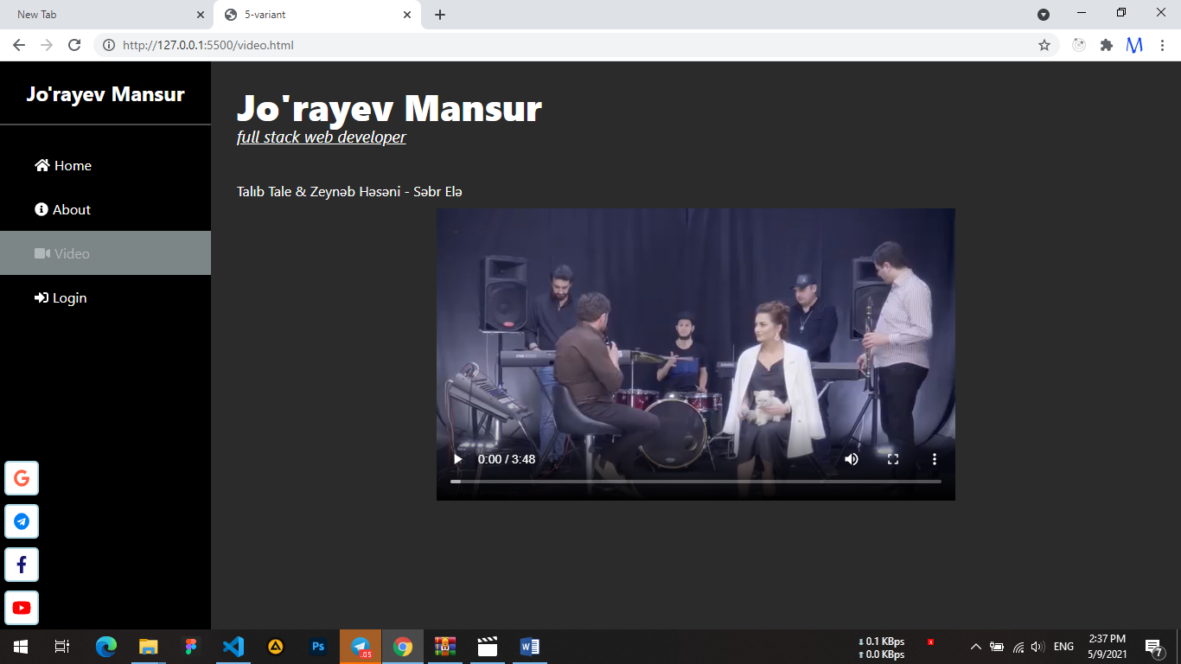

Video.html

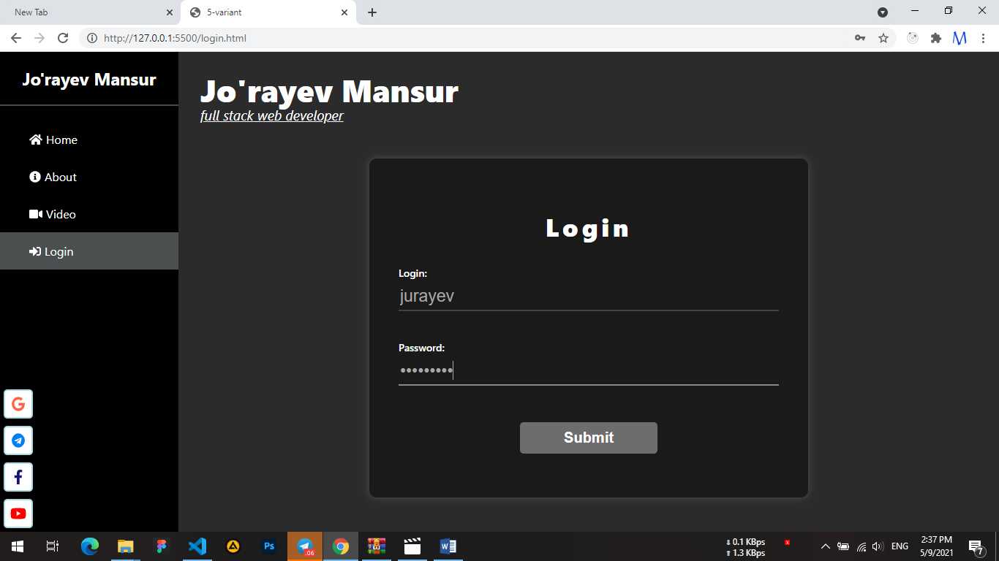

Login.html

Media so’rovlar (Media query ) orqali Mobile, va plashetga responsive qilindi

Iconlarni qo’yishda tashqi Font awesome kutubxonasidan foydalanildi